**FUNCTIONAL AND TECHNICAL COMBINED DOCUMENTATION**

**Page (46): Constructing your Portfolio (Front End Url:** <http://localhost:8100/page46/Page4>6)

**Functional Picture:**

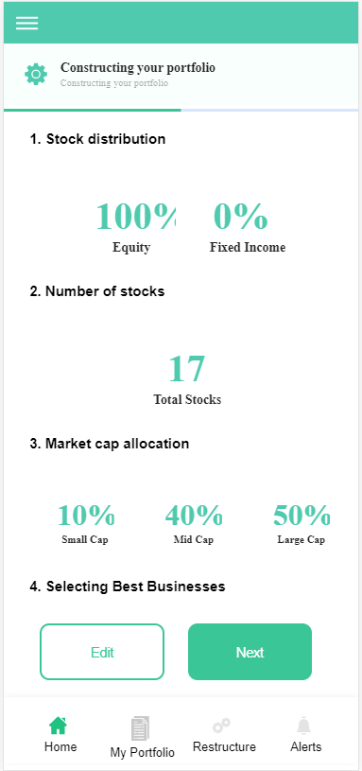

**Technical Explanations (Front End and Back End):**

**In Page46.tsx, we are calling following two API’s:**

1. FinalDivesificationAPI: see view.py python file from BackEnd

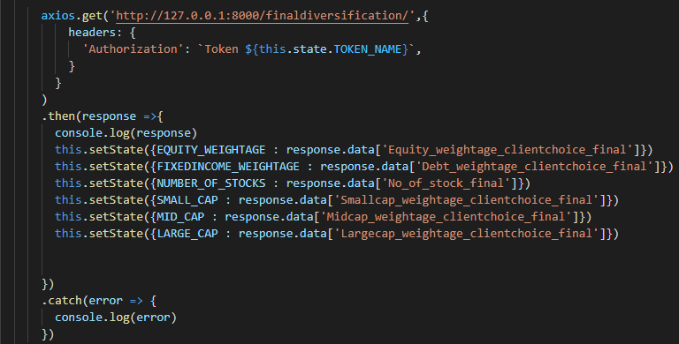

**As you can see above, there is one urls:**

* [**http://127.0.0.1:8000/finaldiversification/**](http://127.0.0.1:8000/finaldiversification/) **--🡪** FinalDivesificationAPI

**From** FinalDivesificationAPI, we are taking the data from **FinalDiversificationStructure** model.

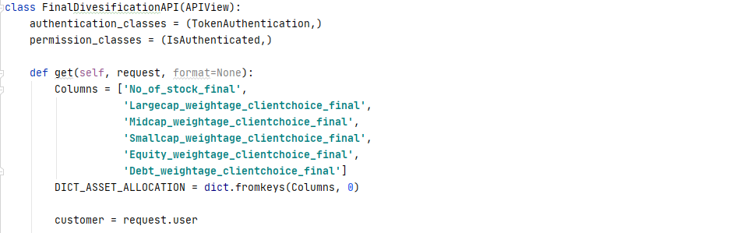

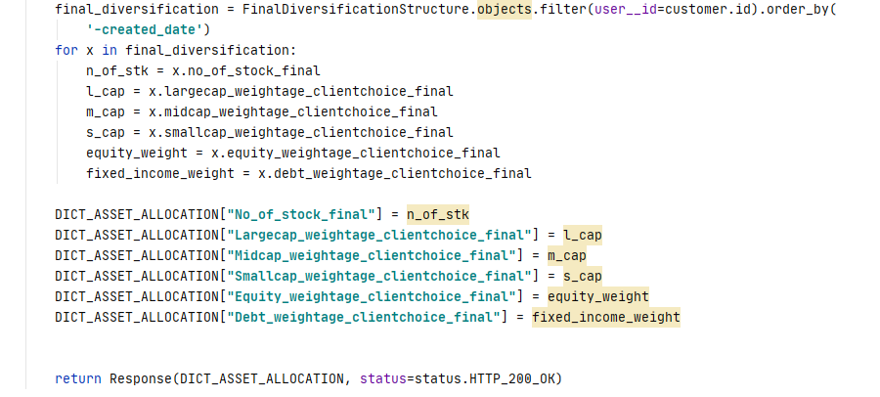

As you can see, we are taking the data from **FinalDiversificationStructure** database according to the user.

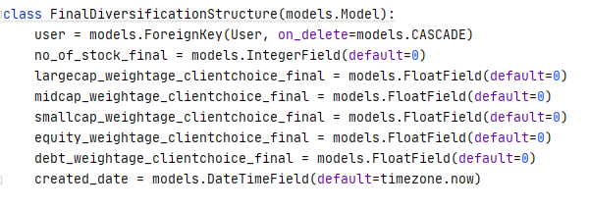

**The above given code snippet is our FinalDiversificatioStructure Database model.**